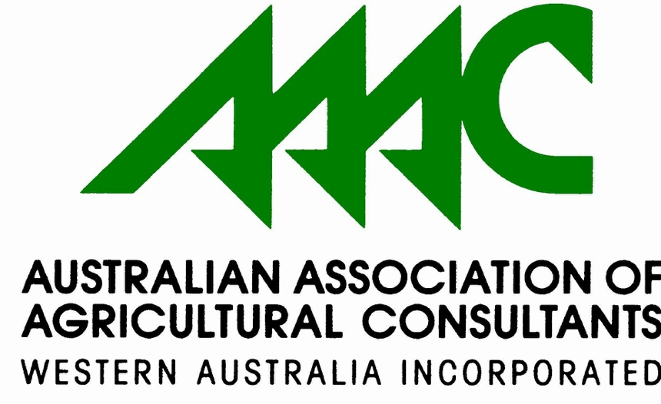

David Bedbrook Bursary
for Students studying a relevant
Agricultural related degree or diploma

Information, Eligibility Criteria
and Application Form

AAAC(WA) is a professional association for agriculture consultants and provides cutting edge professional development, rich networking opportunities and tangible promotion of the profession.

This award honours the memory of the late David Bedbrook. David Bedbrook had a long professional career as an Agricultural Consultant. In recognition of the immense contribution that David made to the Association of Agricultural Consultants (AAAC(WA)) and to consulting as a profession the AAAC(WA) has established the ‘David Bedbrook Bursary’.

www.aaacwa.org.au

AAAC(WA)
DAVID BEDBROOK BURSARY 2021

AAAC(WA) offers two $1,500 bursaries to students who has completed their second year of study towards:

- Agricultural Science or relevant agriculture degree at a Western Australian university or
- Diploma at a Western Australian TAFE college and is enrolled for the 2020 Academic Year.

Please note that this bursary is to be used to cover costs associated with the two-week mentoring, relevant agricultural training course and/or agricultural insertion component of the Bursary ie accommodation, travel, meals.

The David Bedbrook Bursary has been developed to support the next generation of agricultural leaders, who will take up the challenge of farming for the future. It is for young people who are passionate about agriculture, with a keen interest in the future of our industries and who are ready to expand their networks and learn new skills.

ELIGIBILITY
Students who are eligible to apply who :
- are residing in Western Australia in 2021
- are studying towards their first undergraduate degree or diploma at a Western Australian tertiary institution
- have successfully completed all of their second year units/requirements of a degree/diploma course (on a full or part time basis)
- are able to provide at least 1 (one) written academic reference and 1 (one) written personal reference
- demonstrate a commitment to the agriculture industry in WA.

APPLICATIONS – PLEASE NOTE THAT INCOMPLETE APPLICATIONS WILL NOT BE CONSIDERED
Applications must be made on the attached form and sent by email to:
AAAC(WA)
info@aaacwa.org.au
before midnight on 31 March 2021

SHORT LISTING AND INTERVIEW OF APPLICANTS

- All applications are dealt with in confidence
- Short listing and interview of applicants will occur in April 2021
- The successful applicants will be advised in April 2021
- The successful applicants will be invited to attend a meeting of AAAC(WA) in May to receive their award and to give a short address to the Associations members

AAAC(WA)
DAVID BEDBROOK BURSARY 2021

Application Form

The application has six parts: personal details, current tertiary education, activities and achievements, supporting information, references and statement..
ALL PARTS MUST BE COMPLETED

- Personal Details
Surname
Given names
Date of birth
Address
(during academic year)
Postal address
Telephone number
Email

- Current Tertiary Education
Name of University or
TAFE College
Current enrolment degree/diploma course
(include Major)
Year of course commencement
Proposed completion date of degree/diploma
Confirmation of enrolment for 2020, subjects passed and subjects enrolled for 2021. | Please attach to statement of academic record to application
- Activities and Achievements
(Please describe or indicate ‘nil’)
Past or present extra–curricular activities, hobbies, club or organisation memberships (including any offices held), community involvement or other achievements that you consider are relevant
Academic prizes, awards and other academic achievements
Summary of employment or work experience
(past and present)

- Supporting Information
What are your future professional and personal goals?

Please outline how this bursary will assist you in completing your degree

- References
Attach two written references (one professional and one personal) that confirm the applicant’s eligibility and suitability to meet the requirements of the Award.
Name of professional referee (This may be a lecturer)
Email
Telephone
Name of personal referee (This may be someone that has known you a long time).
Email
Telephone
- Statement
The information I have provided in this application is, to the best of my knowledge, true and accurate. Incorrect and/or incomplete information relating to this application is my responsibility and may result in my application being deemed inadmissible and/or the withdrawal of any offer for award.
Signature |  |  | Date
FINAL CHECK:
I have answered all of the questions?
A copy of my latest available tertiary examination results is attached (If selected for interview please bring original documents)
Two written references are attached
I am emailing this before midnight on 31 March 2021

